IMPORT DATA USING TRANSFORM MAPS
(SPREAD SHEET)
Project Development Phase
Creating the Spreadsheet
The first step in the development process is to create an Excel spreadsheet containing the data to be imported into ServiceNow. The spreadsheet should contain proper column headings and valid records.
Example fields:
Employee Name
Employee ID
Email
Department
Location
Each row represents one employee record, and each column represents a specific field.
Preparing the Excel Data
The Excel data is reviewed and prepared before importing it into ServiceNow. Unnecessary blank rows, duplicate records, and incorrect values are removed.
The data format is also checked to ensure that it matches the corresponding fields in the ServiceNow target table.
Creating the Import Set
An Import Set is created in ServiceNow to load the spreadsheet data into the platform. The Import Set provides a temporary staging area where the imported data can be stored before transformation.
The Import Set is configured to receive the data from the Excel spreadsheet.
Uploading the Spreadsheet
The prepared Excel spreadsheet is uploaded into the ServiceNow Import Set. After uploading the file, ServiceNow loads the spreadsheet records into the Import Set Table.
The imported records are checked to ensure that the source data has been loaded correctly.

Creating the Transform Map
A Transform Map is created to define how the imported source data should be transferred to the target ServiceNow table.
The Transform Map connects the Import Set Table with the selected target table and controls the transformation process.
Mapping Source Fields to Target Fields
The source fields from the spreadsheet are mapped to the corresponding fields in the target ServiceNow table.
Example:
Source Field| Target Field
Employee Name| SB0001, SB0002, SB0003, SB0004, SB0005,SB0006
Employee ID| User1,User2, User3, User4, User5, User6
Email| user1@gmail.com, user2@gmail.com, user3@gmail.com, user4@gmail.com, user5@gmail.com,user6@gmail.com,
Department| ServiceNow, ServiceNow, ServiceNow, ServiceNow, Salesforce, Salesforce
Location| Tamil Nadu, Tamil Nadu, Tamil Nadu, Tamil Nadu, Tamil Nadu, Tamil Nadu,
Correct field mapping ensures that the data is transferred to the appropriate fields.
Running the Transform
After completing the field mappings, the Transform Map is executed. ServiceNow processes the records from the Import Set Table and transfers the data into the target table.
The transformation results are checked to identify successfully processed records and any errors.
Verifying Imported Records
After the transformation is completed, the target ServiceNow table is opened and the imported records are verified.
The values in the target fields are compared with the original Excel data to confirm that the records have been imported correctly.

Screenshots Of Implementation
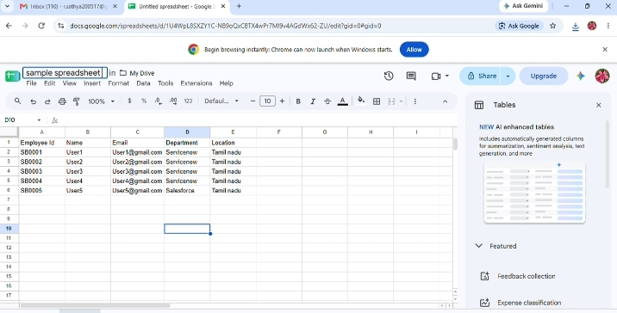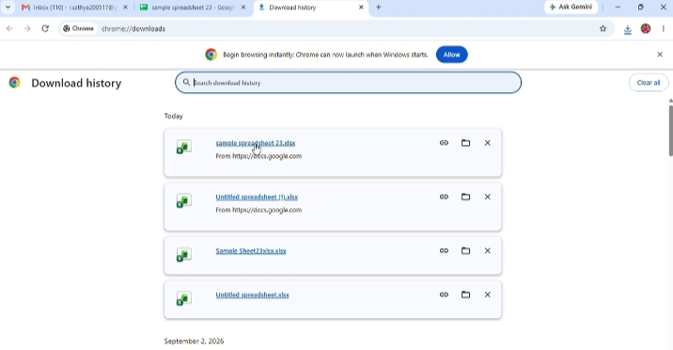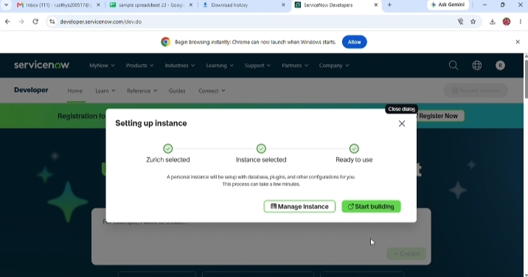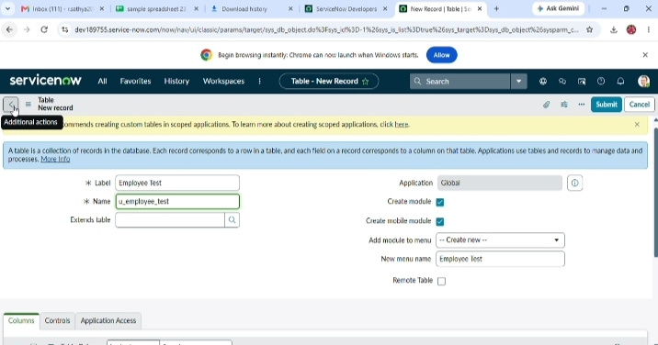

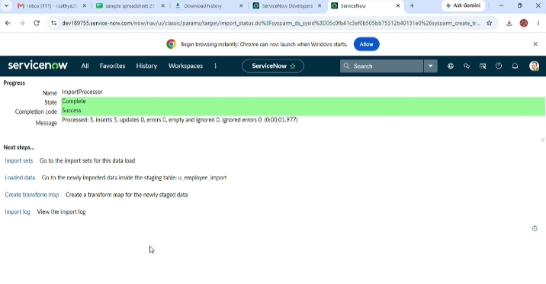

Google Sheet Sample Data
Figure 1: Created a Google Sheet containing sample employee data with fields such as Employee ID, Name, Email, Department, and Location.
Download the Document
Figure 2: Downloaded the sample spreadsheet as an Excel file (.xlsx) from Google Sheets via Chrome Download History.
ServiceNow Instance Setup
Figure 3: Set up a personal ServiceNow developer instance. The Zurich release was selected, and the instance is ready for use.
Create New Table
Figure 4: Created a new custom table named ‘Employee Test’ (u_employee_test) in ServiceNow to store the imported employee data.
Import Complete
Figure 5: Successfully imported the data using the Import Processor. The import state shows as Complete with a Success completion code.

